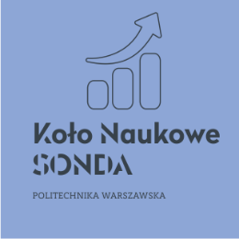

IX International Scientific Conference
Contemporary problems of economic development - Economies during the crisis
June 11, 2021
Application form
First name and last name
Academic degree
 |  | Research worker
 |  | Student
Name and surname of the Student tutor
College
E-mail address
Form of participation |  | Passive participation
 |  | Participation with a research paper without publication
 |  | Participation with a research paper and publication
Title of the paper
Abstract of the paper
(max. 500 characters)

I herby consent to my personal data being processed by Warsaw University of Technology for the purpose of IX International Scientific Conference „Contemporary problems of economic development - Economies during the crisis”.

Date ……………………………. Signature……………………………………..

